ASSESSMENT

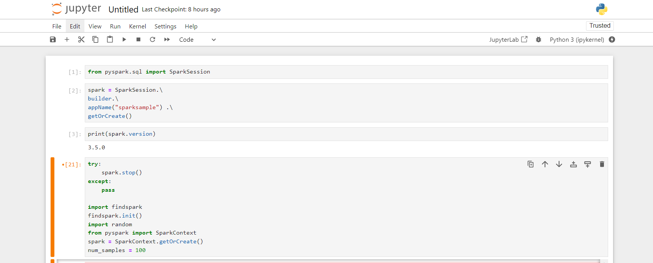

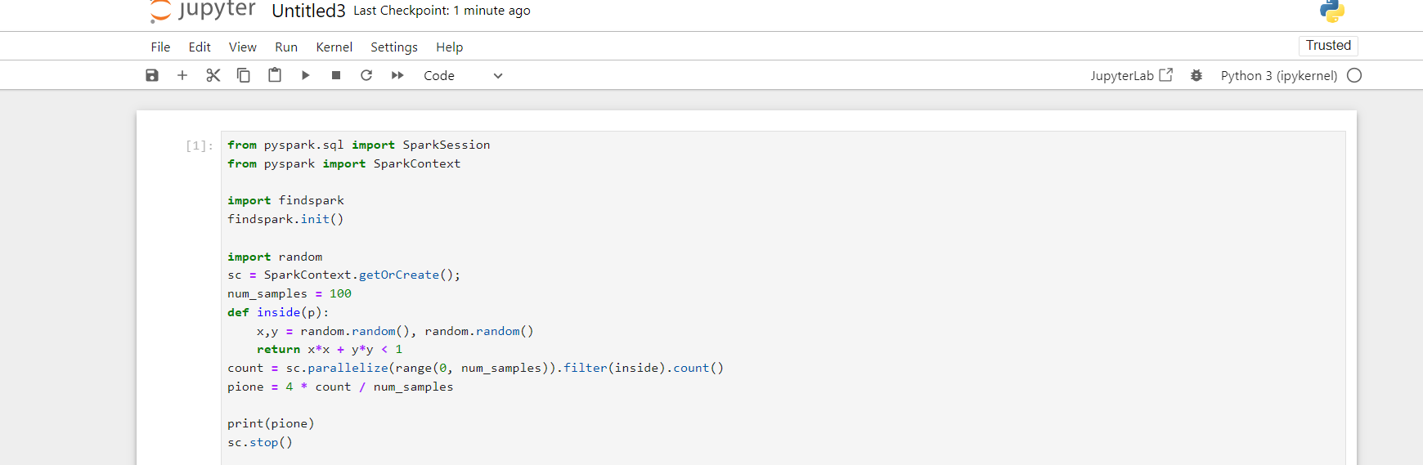

Extract: Retrieve data from various sources like databases, files, or APIs.

Transform: Clean, aggregate, and manipulate data to fit your analysis needs.

Load: Store the transformed data into a database or data warehouse for analysis.